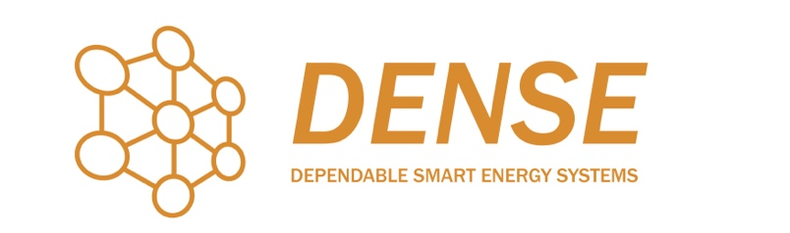
Motivation letter template (Max 2000 words)

First name and Surname of the candidate:
Project Number, Title and name of main Supervisor:
Text of the Letter
The letter must be of maximum 2000 words and include:
- a brief presentation of yourself
- the main reasons for your choice of DC project (why do you think the DC research topic is particularly relevant, timely, important)
- your general knowledge on the research topic of your choice
- your main research and training goals (what do you expect from this doctoral course?)
- your main (research) interests
- your future plans (how do you see yourself in the next 5 and 10 years?)
- your main complimentary skills (e.g. team leadership, working in international teams, languages, communication skills, ability of independent thought, others)
- any other information you might deem as essential

Date, place Signature

